“ATYPICAL TERATOID RHABDOID TUMOR CLASSIFICATION USING VGG-19”

**SUMMER INTENSHIP PROJECT**

**Course Code: SPJ2001**

***“Review-01”***

**By**

**T.K Vamsi Krishna – 21MIC7023**

**A.V.S Hemanth Kumar - 21MIC7052**

**A. Prajwal Sri Tej – 21MIC7107**

**Under the guidance of**

**Prof. Dr. D. Santha Devi**

**School of Computer Science and Engineering**

**VIT-AP University**

**Amaravathi –522237**

**First Review**

**TITLE OF THE PROJECT:** ATYPICAL TERATOID RHABDOID TUMOR (AT/RTs) CLASSIFICATION USING VGG-19.

**PURPOSE OF THE SYSTEM:**

The goal of classifying Atypical Teratoid Rhabdoid Tumours (AT/RTs) with a deep learning model, specifically using Advanced Convolutional Neural Networks (CNNs) like **Visual Geometry Group (VGG-19)**, is to enhance the diagnosis and treatment of this rare and aggressive form of brain cancer. AT/RT primarily affects young children and is difficult to distinguish from other types of brain tumours. Traditional diagnostic approaches, such as biopsies and imaging, can be time-consuming and sometimes inaccurate. Researchers hope to develop a faster, more reliable method of identifying AT/RT from medical imaging and patient data by utilizing CNNs like VGG-19, a type of artificial intelligence that can analyse data sequences. Using enormous volumes of data, this deep learning method can identify patterns that the human eye might overlook. Improved classification using VGG-19 can result in earlier and more accurate diagnoses, allowing for more prompt and effective treatments and, ultimately, better patient outcomes.

**PROBLEMS IN THE EXISTING SYSTEM:**

* **Limited Data Availability:** Because ATRT is rare, there is insufficient labelled data to adequately train CNN models, which require huge datasets to learn accurately.
* **Image Variability:** The quality and look of medical images vary, making it difficult for the model to generalise effectively across diverse datasets.
* **Processing Demands:** CNNs demand a large amount of processing power and time to train, which can be a challenge for many healthcare facilities.
* **Overfitting:** CNNs models perform well on training data but struggle with fresh, previously unknown data, lowering their reliability in real-world circumstances.
* **Interpretability Issues:** Deep learning models are frequently complex and difficult to interpret, making it challenging for clinicians to trust and apply them effectively in clinical settings.

**SOLUTION OF THESE PROBLEMS:**

• Use techniques to generate synthetic data and enhance existing datasets, compensating for the scarcity of labelled ATRT data.

• Adapt pre-trained models on larger datasets to improve performance on varied medical images of ATRT.

• Employ parallel processing and GPU acceleration to reduce training time and resource demands for CNNs.

• Apply methods like dropout and weight decay to mitigate overfitting, improving model generalization capabilities.

• Develop methods to make CNN decisions interpretable, aiding doctors in trusting and applying model outputs in clinical settings.

**SCOPE OF THE PROJECT:**

The scope of the project on classifying **Atypical Teratoid Rhabdoid Tumours (ATRT)** using deep learning, particularly with **Advanced Convolutional Neural Networks (CNNs)** like **Visual Geometry Group (VGG-19)**, is broad and impactful. It aims to advance medical diagnostics by developing a robust system that can accurately identify AT/RT from brain imaging data. The project involves gathering and analysing diverse datasets of medical images, encompassing different variations and qualities, to train and validate the CNN model effectively. By leveraging deep learning techniques, including the VGG-19 architecture, the project seeks to overcome current limitations in AT/RT diagnosis, such as the rarity of the tumour and the complexity of interpreting medical images.

Furthermore, the scope extends to improving computational methods, ensuring the model is efficient enough for practical clinical use. It involves exploring techniques like data augmentation, transfer learning from larger datasets, and optimizing hardware resources to enhance the model's accuracy and speed. The project also includes developing strategies to make the CNN's decisions interpretable for medical professionals, fostering trust and adoption in clinical settings.

Ultimately, the scope of this project is to revolutionize how AT/RT is diagnosed and managed, potentially leading to earlier detection, personalized treatment strategies, and improved outcomes for patients, especially children affected by this aggressive form of brain cancer.

**FUNCTIONAL COMPONENTS OF THE PROJECT:**

Classifying **Atypical Teratoid Rhabdoid Tumour (ATRT)** using **Convolutional Neural Networks (CNNs)** model involves several functional components, each crucial for the development and deployment of the model. Below is an overview of these components:

**1. Data Collection and Preprocessing:**

* **Data Sources**: Obtain a comprehensive dataset of medical images (e.g., MRI, CT scans) and associated metadata from hospitals, research institutions, or publicly available databases.
* **Data Annotation**: Ensure images are labelled accurately by medical professionals, indicating whether they show ATRT or other conditions.
* **Data Cleaning**: Remove duplicates, correct inconsistencies, and handle missing values.
* **Normalization**: Scale pixel values of images to a uniform range, typically [0, 1] or [-1, 1].
* **Augmentation**: Apply transformations like rotation, flipping, zooming, and shifting to increase dataset size and variability.

**2. Model Architecture Design:**

* **CNN Selection**: Choose the type of Advanced CNN (e.g., VGG) based on the specific requirements of handling sequential data.
* **Layers Configuration**: Configure input, hidden, and output layers. For image data, consider using a combination of Convolutional Neural Networks (CNN) to extract spatial features followed by Advanced CNN for temporal analysis.
* **Activation Functions**: Select appropriate activation functions (e.g., VGG for CNN layers, Sigmoid or SoftMax for output layers).
* **Loss Function**: Choose a loss function suitable for classification tasks, such as categorical cross-entropy.

**3. Model Training:**

* **Training/Validation Split**: Divide the dataset into training, validation, and test sets to evaluate model performance.
* **Optimization Algorithm**: Use algorithms like Adam, RMSprop, or SGD to minimize the loss function.
* **Hyperparameter Tuning**: Adjust learning rate, batch size, number of epochs, and other hyperparameters to improve model performance.
* **Regularization**: Implement dropout, image normalization, or weight decay to prevent overfitting.

**4. Model Evaluation:**

* **Performance Metrics**: Use metrics like accuracy, loss to assess model performance.

**5. Model Deployment:**

* **Export Model**: Save the trained model in a suitable format (e.g., TensorFlow/Kera’s models).
* **API Development**: TensorFlow and Flask for API’s.
* **User Interface**: Develop a front-end interface for clinicians to upload images and receive predictions.

**6. Monitoring and Maintenance:**

* **Model Monitoring**: Continuously monitor model performance in the real world to detect drifts or performance degradation.
* **Periodic Retraining**: Update the model with new data periodically to maintain accuracy and relevance.
* **Feedback Loop**: Implement a system for users to provide feedback on model predictions to improve future iterations.

**7. Documentation and Reporting:**

* **Model Documentation**: Document the model architecture, training process, evaluation metrics, and deployment steps.
* **Clinical Reports**: Generate reports summarizing the findings and potential clinical implications of the model.

**STUDY OF THE SYSTEM:**

The system after careful analysis has been identified to be presented with the following

**Modules:**

**Number of Modules:**

* Home
* Scan
* About
* Contact

**INPUT / OUTPUT Specifications:**

**Input Specifications:**

1. **Medical Images**
   * **Format**: PNG, JPEG, JPG
   * **Resolution**: High-resolution images, typically standardized to a specific size (e.g., 240x240 pixels) for consistency.
   * **Modality**: MRI or CT scans are commonly used.
   * **Channel**: Grayscale (single channel) or RGB (three channels), depending on the imaging technology.
2. **Image Preprocessing Parameters**
   * **Normalization Factors**: Values used to normalize pixel intensities.
   * **Augmentation Settings**: Details of any image augmentations applied (e.g., rotations, flips).
3. **Training Parameters (for model training phase)**
   * **Learning Rate**: Initial learning rate for the optimizer.
   * **Batch Size**: Number of samples processed before updating the model.
   * **Epochs**: Number of complete passes through the training dataset.
   * **Validation Split**: Proportion of data used for validation during training.

**Output Specifications:**

1. **Classification Output**
   * **Label**: Predicted class label for each input image (e.g., "ATRT" or "Non-ATRT").
   * **Confidence Scores**: Probability scores for each class, indicating the model's confidence in its predictions.
2. **Performance Metrics (for model evaluation)**
   * **Accuracy**: Overall accuracy of the model on the test dataset.
   * **Loss**: Measures overall loss of the model on the test dataset.

**PERFORMANCE REQUIREMENTS:**

**Functional Requirements**

* **Accuracy**: The model should achieve a classification accuracy of at least 90% on the test dataset. This ensures that the model is reliable in distinguishing ATRT from other types of tumours.
* **Loss**: Loss measures the difference between the predicted values and the actual values, quantifying the error in a model's predictions.

**Non-Functional Requirements**

* **Scalability**: The model should be scalable to handle large datasets and increasing numbers of imaging slices without significant degradation in performance.
* **Robustness**: The model should be robust to variations in imaging modalities, ensuring consistent performance across different types of MRI and CT scans.
* **Generalizability**: The model should generalize well to new, unseen data from different medical institutions and imaging devices.
* **Resource Efficiency**: The model should be optimized to run efficiently on available hardware, including GPUs for training and CPUs for inference, without requiring excessive computational resources.
* **Interoperability**: The system should be compatible with existing medical imaging software and databases, facilitating easy integration into clinical workflows.

**Technical Requirements**

* **Data Preprocessing**:
  + Normalization of image intensities across different scans.
  + Segmentation of tumour regions with high accuracy.
  + Augmentation of data to increase diversity and prevent overfitting.
* **Network Architecture**:
  + Implementation of an CNN, specifically using VGG-19 layers to capture sequential dependencies.
  + Inclusion of fully connected and SoftMax layers for final classification.
* **Training Protocol**:
  + Use of a cross-entropy loss function.
  + Optimization with the Adam optimizer.
  + Application of early stopping and dropout to prevent overfitting.
* **Evaluation Metrics**:
  + Use of accuracy and loss for comprehensive performance evaluation.
* **Hyperparameter Tuning**:
  + Systematic tuning of hyperparameters, such as learning rate, batch size, and number of VGG-19 layers, using grid search or other optimization techniques.

**Usability Requirements**

* **User Interface**: The system should have an intuitive user interface for clinicians, providing easy access to classification results and visualization of tumor regions.
* **Documentation and Training**: Comprehensive documentation and training materials should be provided to ensure users can effectively operate the system and interpret the results.
* **Support and Maintenance**: Ongoing technical support and regular maintenance updates should be available to address any issues and incorporate improvements based on user feedback.

**Security and Privacy Requirements**

* **Data Security**: The system should ensure the security of medical imaging data during transmission, storage, and processing, complying with relevant regulations (e.g., HIPAA).
* **Privacy Protection**: Patient privacy must be protected, with anonymization of data where necessary and access controls to prevent unauthorized use.

**FEASIBILITY REPORT:**

**Technical Feasibility**

The implementation of an CNN (Convolutional Neural Networks) model for the classification of Atypical Teratoid Rhabdoid Tumor (ATRT) is technically feasible due to the following reasons:

1. **Data Availability**:
   * **Medical Imaging Data**: Sufficient labelled datasets of MRI or CT scans are available through medical institutions and public repositories.
   * **Preprocessing Tools**: Existing tools and libraries for medical image preprocessing (such as Keras Image Data Generator.) can be used to prepare the data for training.
2. **Model Architecture**:
   * **CNNs for Sequence Data**: Advance CNNs are well-suited for sequential data. For medical imaging, sequences of images (slices of scans) can be used to capture spatial dependencies.
   * **Advanced Variants**: Advanced CNN architectures can be employed to address the vanishing gradient problem and capture long-term dependencies.
3. **Computational Resources**:
   * **Hardware**: Modern GPUs and cloud-based services provide the necessary computational power for training deep learning models.
   * **Software**: Deep learning frameworks like TensorFlow and PyTorch support CNNs and provide efficient implementations for training and inference.
4. **Model Training and Evaluation**:
   * **Training**: The availability of powerful optimization algorithms and techniques such as learning rate scheduling and regularization can ensure effective model training.
   * **Evaluation**: Robust evaluation metrics (accuracy, loss) and cross-validation techniques can be used to validate model performance.

**Operational Feasibility**

Operational feasibility focuses on the practical implementation and deployment of the CNN model in a clinical setting:

1. **Integration with Clinical Workflow**:
   * **Ease of Use**: The model can be integrated into existing hospital information systems (HIS) and Picture Archiving and Communication Systems (PACS) for seamless usage by radiologists and medical practitioners.
   * **User Interface**: Development of a user-friendly interface for radiologists to input data and receive classification results in a clear and interpretable format.
2. **Maintenance and Support**:
   * **Regular Updates**: The model can be regularly updated with new data to improve accuracy and robustness.
   * **Technical Support**: Provision of technical support and training for medical staff to ensure smooth operation.
3. **Regulatory Compliance**:
   * **Approval**: Adherence to medical device regulations and obtaining necessary approvals from health authorities (e.g., FDA, EMA).
   * **Data Privacy**: Ensuring compliance with data protection regulations (e.g., HIPAA, GDPR) to safeguard patient information.
4. **Scalability**:
   * **Deployment**: Scalable deployment options using cloud infrastructure to handle varying workloads and ensure high availability.
   * **Adaptability**: Flexibility to adapt the model for different types of tumors or other medical conditions in the future.

**Economic Feasibility**

The economic feasibility assesses the cost-effectiveness and financial viability of the project:

1. **Development Costs**:
   * **Initial Investment**: Costs related to data acquisition, model development, and initial deployment. This includes expenses for computational resources, software licenses, and personnel (data scientists, engineers, medical experts).
   * **Ongoing Costs**: Regular maintenance, model updates, and technical support.
2. **Cost-Benefit Analysis**:
   * **Improved Diagnosis**: Early and accurate diagnosis of ATRT can lead to better treatment outcomes, potentially reducing overall treatment costs.
   * **Operational Efficiency**: Automation of tumour classification can reduce the workload of radiologists, leading to cost savings in labour.
3. **Funding and ROI**:
   * **Funding Sources**: Potential sources of funding include grants from medical research organizations, government funding, and private investments.
   * **Return on Investment**: Expected ROI from improved patient outcomes, operational efficiencies, and potential commercialization of the model.
4. **Market Potential**:
   * **Healthcare Market**: Growing demand for AI-based diagnostic tools in healthcare presents a significant market opportunity.
   * **Competitive Advantage**: Offering a unique solution with high accuracy and reliability can provide a competitive edge in the market.

**Data Flow Diagrams:**

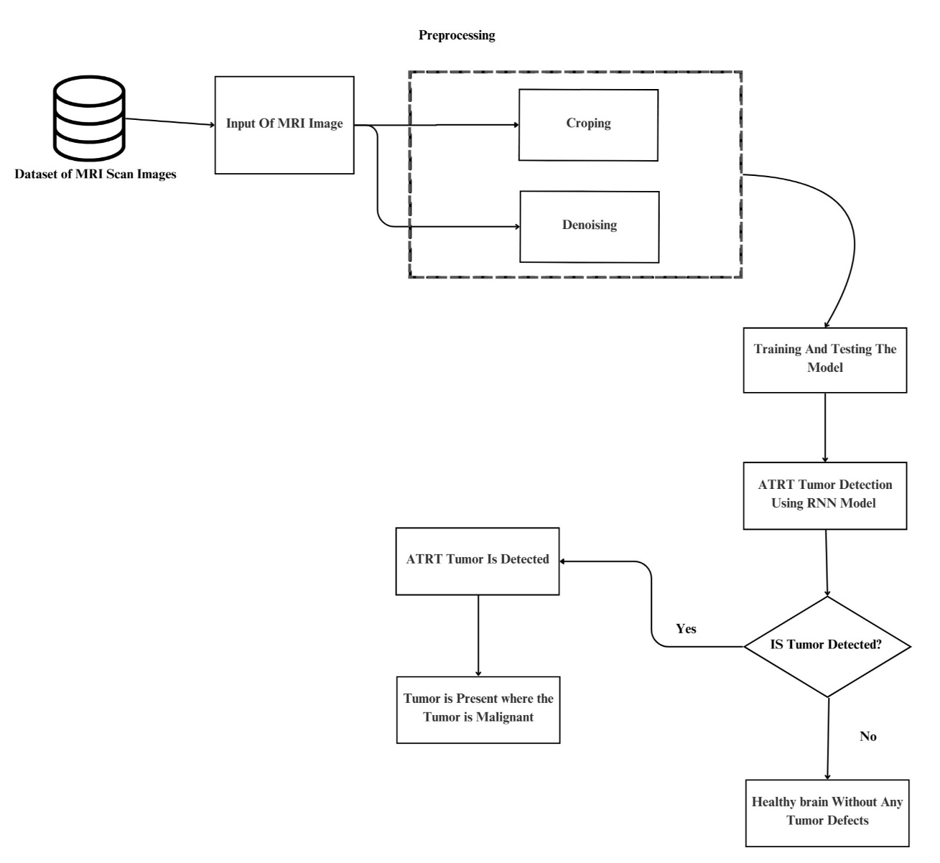

**Architecture Diagram:**

